A

AUDIT COURSE REPORT

ON

“COPYRIGHTS AND PATENTS”

SUBMITTED TO THE SAVITRIBAI PHULE PUNE UNIVERSITY, PUNE FOR THE PARTIAL FULFILLMENT FOR THE AWARD OF THE DEGREE
OF

BACHELOR OF ENGINEERING IN INFORMATION TECHNOLOGY BY
Rajvardhan Deshmukh 43219
Under the guidance of MR. Manish Khodaskar
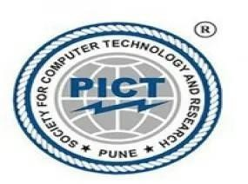

DEPARTMENT OF INFORMATION TECHNOLOGY
PUNE INSTITUTE OF COMPUTER TECHNOLOGY, PUNE
Sr. No. 27, Trimurti Chowk, Dhankawadi, Pune-43

AY 2025-26

TITLE

NAME OF TOPIC: Copyrights and Patents

STUDENT NAME: Rajvardhan Haridas Deshmukh

NAME OF COLLEGE: Pune Institute of Computer Technology COURSE: B.E. (Information Technology)

CLASS: BE – 10

ROLL NO: 43219

NAME OF GUIDE: Mr. Manish Khodaskar

ACKNOWLEDGEMENT

The success and final outcome of this project required a lot of guidance and assistance from many people and I am extremely privileged to have got this all along the completion of my project. All that I have done is only due to such supervision and assistance and I would not forget to thank them.

I respect and thank Mr. Manish Khodaskar, for providing me an opportunity to do the project work in “COPYRIGHTS AND PATENTS” and giving us all support and guidance which made me complete the project duly. I am extremely thankful to her for providing such nice support and guidance, although she had a busy schedule.

I would not forget to remember our Director Dr. P.T. Kulkarni and our Principal Dr. S.T. Gandhe, for their encouragement and heartily thank our Head of the Department Dr. Emmanuel Mark.

I am thankful to and fortunate enough to get constant encouragement, support and guidance from all Teaching staff of the Department of Commerce which helped us in successfully completing our project work.

Rajvardhan Deshmukh

CONTENTS

- Introduction to Copyrights and Patents
- Understanding Patents
- Understanding Copyrights
- Key Differences Between Patents and Copyrights
- Duration of Protection
- Role of International Organizations
- Patent Licensing and Commercialization
- Copyright Licensing and Monetization
- Applications of Patents and Copyrights
- Conclusion
- References

INTRODUCTION TO COPYRIGHTS AND PATENTS

Intellectual Property Rights (IPRs) are legal rights that protect creations of the mind. Among the most prominent forms of IPR are Patents and Copyrights. While both provide creators with exclusive rights over their works, they protect fundamentally different types of intellectual assets.

A patent protects novel inventions and processes, such as a new machine, a chemical compound, or a unique manufacturing method. It gives the inventor the right to prevent others from making, using, or selling the patented invention for a limited period. In contrast, a copyright protects the expression of ideas in a tangible form, such as literary works, music, art, and computer software. It grants the author exclusive rights to reproduce, distribute, perform, and display their creative work.

In today’s innovation-driven economy, understanding the distinction and application of both copyrights and patents is crucial for inventors, artists, engineers, and businesses to protect their creations and gain a competitive advantage.

UNDERSTANDING PATENTS

A patent is an exclusive right granted for an invention, which is a product or a process that provides a new way of doing something or offers a new technical solution to a problem. It provides protection for the invention to the owner of the patent for a limited period, which is generally 20 years.

Key aspects of a patent include:
- Exclusivity: Patent protection means that the invention cannot be commercially made, used, distributed, or sold without the patent owner's consent.
- Licensing and Sale: A patent owner has the right to decide who may or may not use the patented invention. The owner may license other parties to use the invention or sell the right to the invention to someone else.
- Public Domain: Once a patent expires, the protection ends, and the invention enters the public domain, becoming available for commercial exploitation by others

UNDERSTANDING COPYRIGHTS

Copyright is a legal term describing rights given to creators for their literary and artistic works. It protects the original expression of an idea, but not the idea itself.

- Works Covered: The kinds of works covered by copyright include literary works (novels, poems, compute
- r programs), databases, films, musical compositions, artistic works (paintings, photographs, sculpture), architecture, and advertisements.
- Automatic Protection: Copyright protection is automatic upon the creation of the work in a tangible form. While registration is not mandatory, it serves as public proof of ownership.
- Economic Rights: Creators often sell or license the rights to their works to companies that can market them, often in return for payments called royalties.
- Duration: These economic rights have a time limit. For most works, this period is the life of the author plus sixty years after their death

KEY DIFFERENCES BETWEEN PATENTS AND COPYRIGHTS

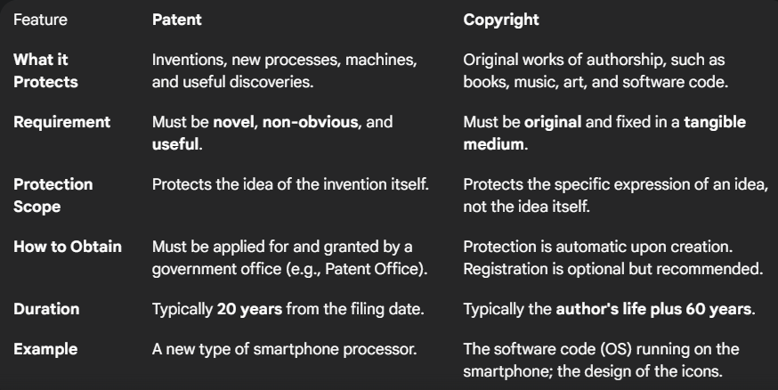
ROLE OF INTERNATIONAL ORGANIZATIONS

Several international organizations play a key role in standardizing and administering intellectual property laws globally.
- WIPO (World Intellectual Property Organization): Established in 1970, WIPO is dedicated to developing a balanced and accessible international IP system. Its functions include harmonizing national IP legislation, providing services for international applications, and offering technical assistance to developing countries.
- WTO (World Trade Organization): Born on January 1st, 1995, the WTO oversees and administers global trade agreements, including the Agreement on Trade-Related Aspects of Intellectual Property Rights (TRIPS). The TRIPS agreement sets minimum standards for the regulation of many forms of IP that member countries must adhere to

PATENT LICENSING AND COMMERCIALIZATION

Commercialization is the process of introducing a new product or service into the market. For patent holders, this is often achieved through licensing.
A patent licensing agreement allows the inventor (licensor) to grant permission to another party (licensee) to make, use, or sell the patented invention in exchange for regular payments, known as royalties. This can be a more lucrative strategy than an outright sale of the patent rights. Licensing allows inventors to monetize their patents without having to build the manufacturing and distribution infrastructure themselves

COPYRIGHT LICENSING AND MONETIZATION

Similar to patents, copyrights are valuable assets that can be monetized. Copyright licensing is the primary method for this.
An author or creator can grant licenses for others to use their work in specific ways. For example:
- A novelist can license film rights to a movie studio.
- A musician can license their song for use in a commercial or video game.
- A software developer can license their program to users.
These licenses generate income for the creator, often through royalties, which are payments made based on the usage or sales of the work. This allows creative works to be widely distributed and enjoyed while ensuring the creator is compensated

APPLICATIONS OF PATENTS AND COPYRIGHTS

Patents and copyrights are applicable across numerous fields to protect different kinds of innovation and creativity.
Applications of Patents:
- Pharmaceuticals: Protecting new drug formulations and medical devices.
- Technology & Electronics: Securing rights for new hardware, software algorithms, and telecommunication methods.
- Manufacturing: Granting exclusivity over new industrial processes and machinery.
- Biotechnology: Protecting genetically modified organisms and new scientific procedures.
Applications of Copyrights:
- Publishing & Media: Protecting books, articles, newspapers, and magazines.
- Entertainment: Covering films, musical compositions, sound recordings, and scripts.
- Software Development: Protecting the source code and object code of computer programs.
- Marketing & Design: Safeguarding advertisements, graphic designs, and architectural plans

CONCLUSION

Patents and Copyrights are fundamental pillars of the intellectual property system. They safeguard creators and inventors by granting them time-limited exclusive rights to control and benefit from the use of their works.
A patent protects the novelty and utility of an invention, fostering technological advancement by rewarding innovation. In contrast, a copyright protects the originality of artistic and literary expression, enriching our culture and creative industries. While they serve different purposes, both are essential legal tools that drive economic growth, encourage progress, and ensure that those who contribute to science and the arts are rightfully recognized and rewarded for their efforts.

REFERENCES

- Singh R. Vol. 1. New Delhi: Universal Law Publishing Co. Pvt. Ltd; 2004. Law relating to intellectual property (A complete comprehensive material on intellectual property covering acts, rules, conventions, treaties, agreements, case-Law and much more).
- Bainbridge DI. New York: Longman; 2002. Intellectual property.
- Anonymous. The Design Act. 2000 along with Design Rules 2001. New Delhi: Universal Law Publishing Co. Ltd; 2004.
- Anonymous. The Trademarks Act 1999 along with trade Marks Rules 2002. New Delhi: Commercial Law Publisher (India) Pvt. Ltd; 2004.
- New Delhi: Department of Science and Technology (DST), Government of India; 2002. Anonymous. Research and development statistics.

